Western Klamath Restoration Partnership

Geographic Scope
(Area in yellow)
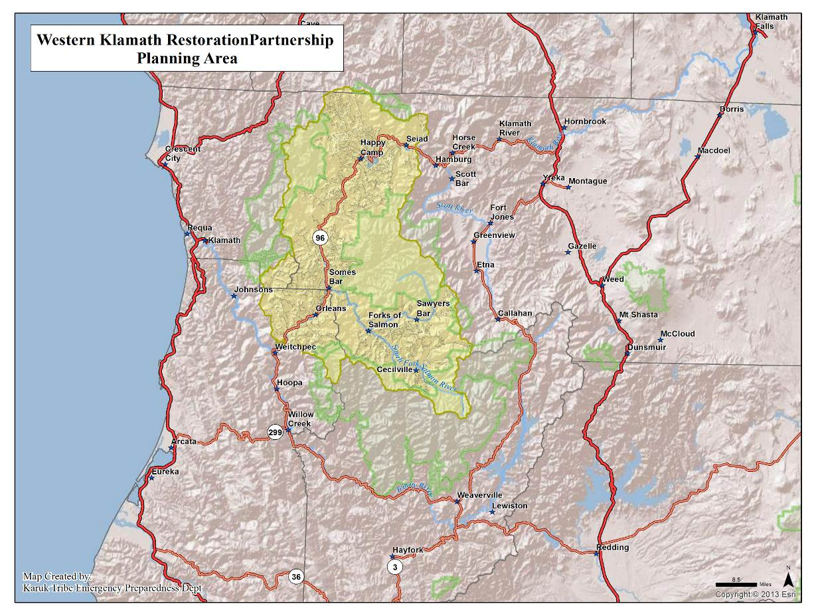

Vision
Establish and maintain resilient ecosystems, communities, and economies guided by cultural and contemporary knowledge through a truly collaborative process that effectuates the revitalization of continual human relationships with our dynamic landscape.

Shared Values
Equal in importance

- Sustainable local economies
- Cultural and community vitality – includes food security and balanced human-fire relationship
- Fire-adapted communities
- Restored fire regimes
- Resilient, biodiverse forests, plants and animals
- Healthy river system

Strategies
Labeled for convenience, no priority

- Develop and implement landscape level strategic fuels reduction treatments
- Increase use of fire to restore & maintain Pre-European conditions in a contemporary context
- Increase local restoration capacity
- Create sustainable diverse revenue streams to address all threats and values
- Accelerate development of Fire Adapted Communities
- Integrate food security into forest management actions
- Advocate for and support implementing existing fisheries restoration plans
- Develop integrated, inter-generational education programs and activities that complement our identified strategies
- Develop inclusive partnerships for implementing zones of agreement (formerly - Improve inter-governmental and community coordination and communication efforts)

Guiding Principles: The Way We Work

- We are results-oriented.
- We work toward having beneficial fire operating throughout our landscape.
- We incorporate cultural values and traditional ecological knowledge into our work.
- Our activities seek to build our local workforce.
- We use the Open Standards for the Practice of Conservation as our guide to adaptive management and collaboration.

Implementation Activities

Activities currently revolve around three focal areas, in which the group explores multiple strategies across boundaries, on behalf of the group’s vision, values and guiding principles.

- Happy Camp Integrated Fire Management Project
- Somes Bar Integrated Fire Management Project
- Salmon River Integrated Fire Management Project

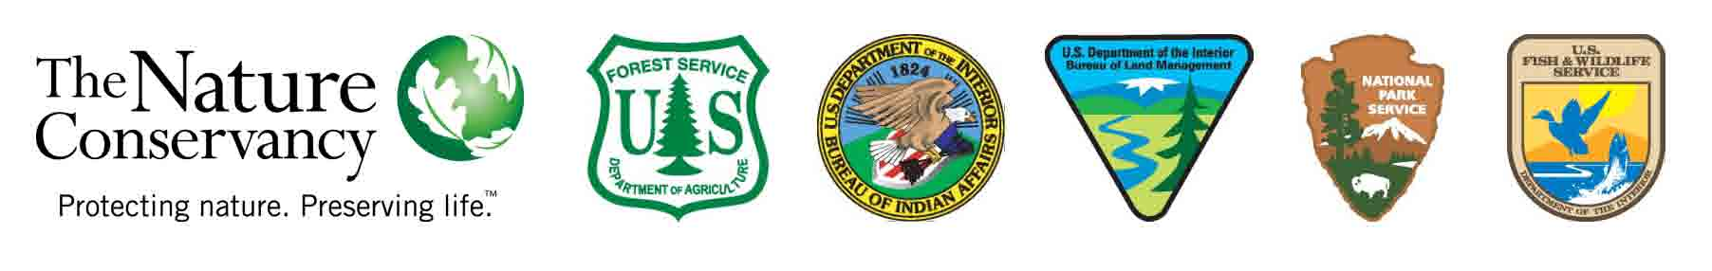
The Western Klamath Restoration Partnership is supported by Promoting Ecosystem Resiliency through Collaboration: Landscapes, Learning and Restoration, a cooperative agreement between The Nature Conservancy, USDA Forest Service and agencies of the Department of the Interior. For more information, contact Lynn Decker at ldecker@tnc.org or (801) 320-0524.

